**PNAMH Hosts Successful “Lunch for a Cause” to Support Cherry Medrano’s Recovery**

**Jonathan Gecomo, DNP, RN, NI-BC, Danny Lindog, BSN, RN, CNOR, Ann Tongol, BSN, RN**

On **August 24, 2024**, the **Philippine Nurses Association of Metro Houston (PNAMH)** and the **Filipino Cancer Network of America (FCNA)** joined forces to host a heartwarming and impactful **“Lunch for a Cause”** event. Held at **Filipiniana Restaurant** in Houston, Texas, this gathering was dedicated to raising funds for **Cherry Sloan-Medrano**, the former PNAMH President and current FCNA President, who is on a long journey of recovery following a stroke.

Cherry Medrano has been a pivotal figure in the nursing and Filipino-American communities in Houston for decades. As a past PNAMH president, founder and president of Filipino Cancer Network of America and a tireless advocate for cancer awareness and nursing organization, she has touched the lives of countless people through her work. Now, after her stroke, the community is coming together to support her as she focuses on her rehabilitation and medical recovery.

**A Day of Compassion and Support**

The event, which began at noon, welcomed dozens of PNAMH members, community leaders, and friends of Cherry Medrano to enjoy a delicious buffet lunch while contributing to a worthy cause. Held at one of Houston’s beloved Filipino establishments, **Filipiniana Restaurant**, attendees mingled, shared stories, and expressed their admiration and gratitude for Cherry’s service and dedication over the years.

The **donation fee** for attending the event was **$25**, and many participants contributed even more to the cause. Attendees were also given the opportunity to donate electronically through **Zelle**, making it easy for everyone to participate, whether in person or remotely. The response from the community was overwhelming, and by the end of the day, **over $3,700** was raised to support Cherry’s ongoing medical and rehabilitation expenses.

**An Outpouring of Community Support**

Cherry Medrano’s contributions to the Filipino nursing community and her leadership in both PNAMH and FCNA have made her a beloved figure. As the former PNAMH President, she worked to promote Filipino-American nurses, advocate for better healthcare policies, and support underserved populations in Houston. She also dedicated much of her life to helping cancer patients and their families, serving as a compassionate founder and leader within the Filipino Cancer Network of America.

In her time of need, it was only natural that the Filipino-American community would rally around her. The **Lunch for a Cause** provided an opportunity for her friends, colleagues, and the broader community to show their support in a tangible way. More than just a fundraiser, the event served as a testament to the strong bonds of friendship, service, and solidarity that exist within the PNAMH family.

**Cherry Medrano: A Legacy of Service**

Cherry’s story is one of resilience, not only as a healthcare leader but also as a patient now navigating her own health journey. Attendees at the event were reminded of the countless times she has extended a helping hand to others—now, it is the community’s turn to support her.

During the event, several attendees shared moving stories of Cherry’s impact. Many spoke of her **courage**, **dedication**, and the **warmth** she brought to every project she was involved in. Her leadership in nursing and cancer awareness initiatives has left a lasting legacy, one that will continue to inspire future generations of nurses and healthcare advocates.

**Continuing the Effort**

While the **Lunch for a Cause** successfully raised over $3,700, the road to recovery for Cherry Medrano is long. Rehabilitation after a stroke can be physically, emotionally, and financially draining. PNAMH and FCNA have pledged to continue their efforts in supporting Cherry’s recovery, whether through additional fundraisers, awareness campaigns, or personal outreach.

The **Philippine Nurses Association of Metro Houston** encourages anyone who was unable to attend the event to contribute via Zelle or reach out to the event coordinators, **Danny Lindog**, **Ann Tongol**, or **Luz Reyes**, for more information on how to support Cherry’s recovery.

**A Future of Hope and Healing**

The success of this **Lunch for a Cause** event is a reflection of the deep connections that Cherry Medrano has built within the community. As the former PNAMH President focuses on her healing, she can take comfort in knowing that she is not alone in this journey. The support and love of the Filipino-American community in Houston are behind her every step of the way.

In these challenging times, the PNAMH once again demonstrated its commitment to the values of **family, compassion, and service**, rallying around one of its own. Cherry’s leadership and spirit have made a lasting mark on the community, and through efforts like these, her legacy continues to thrive.

For those looking to learn more about how they can contribute to Cherry Medrano’s recovery, please visit the [**www.pnamh.net**](http://www.pnamh.net) **or** contact the event organizers for more information. Together, we can make a difference and help Cherry on her path to recovery.

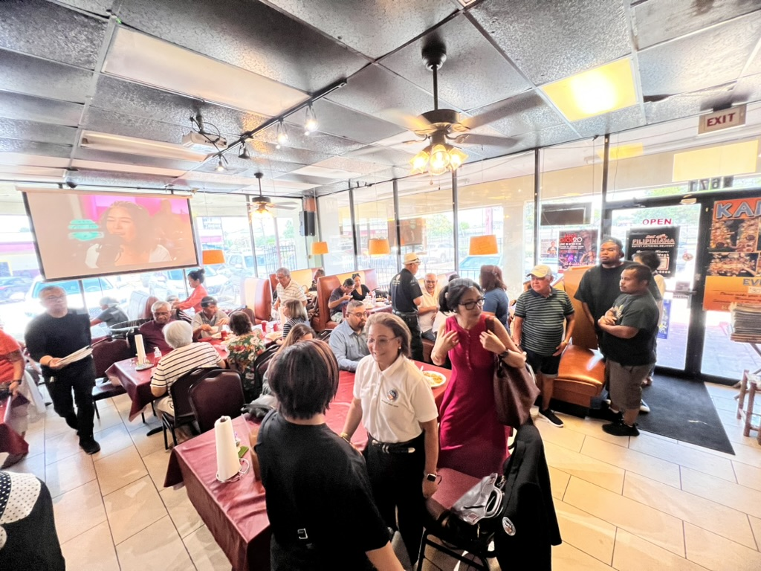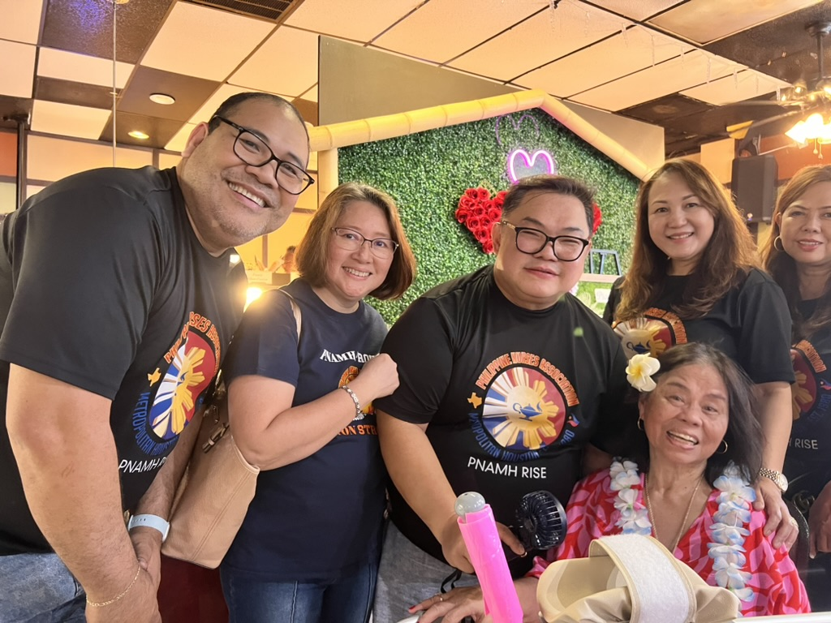Cherry Medrano with PNAMH Executive Board

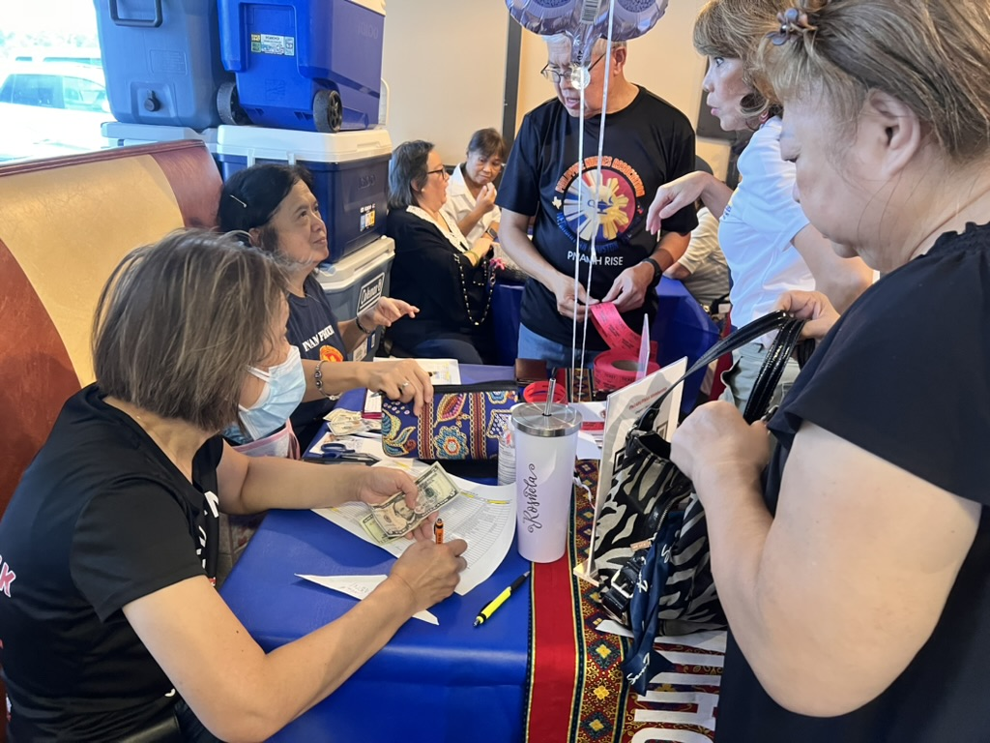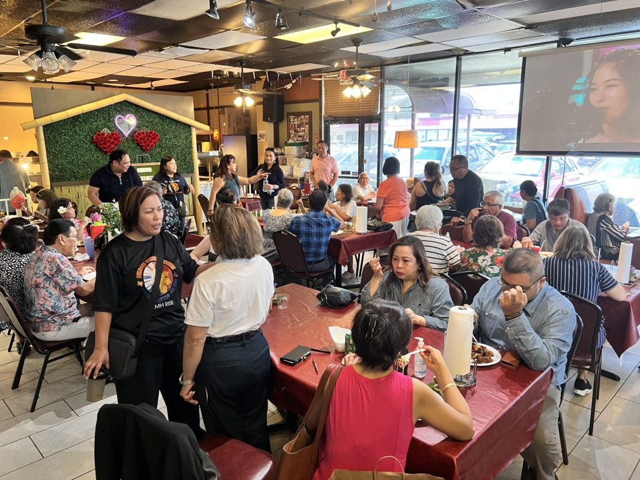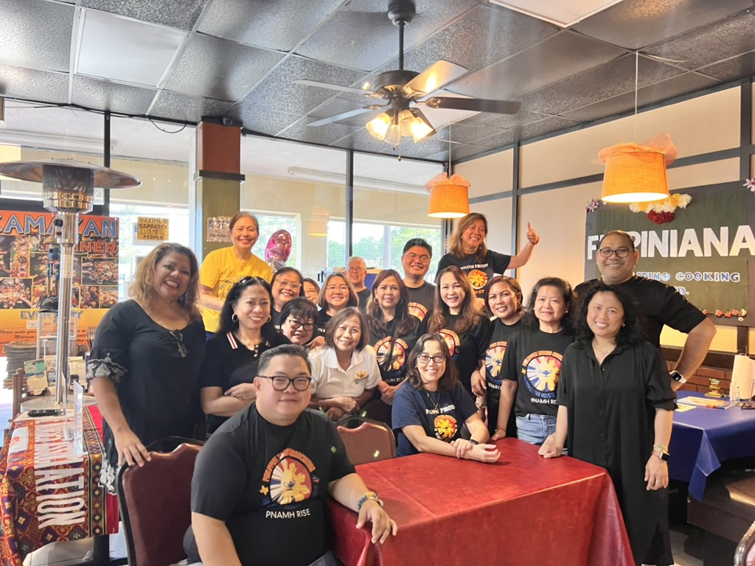PNAMH 2024-2026 Executive Board

